Supply of Assorted Dignity Kits for Women and Girls Centers (WGCs)
Ref No. SD-MC-485615-GO-RFQ
Clarification to Queries
- Is it Possible to apply in USD?
Response: Yes, bidding in USD is permitted provided that the bidding company holds a corporate bank account in Sudan under the exact same name as the officially registered entity submitting the bid.
- Is it possible to indicate the Size for the bag in centimeters, which will help us in identifying the Unite Price ex (40*60).
Response: A bag size of 40cm width * 50cm height/length; and a bottom gussets of 15cm.
- Which one of the bath soaps is preferred, as many soaps are in the market with a difference in price (Do you have STANDARD One Like Lifebuoy of Dettol).
Response: Standard brands such as Lifebuoy or Dettol (or their technical equivalents) are fully acceptable.
- Regarding Slippers, is it the Medical one or just the Normal one?
Response: Standard (normal) slippers are required; medical-grade slippers are not necessary for this contract.
- For Sanitary Pads, is it one-time use or reusable?
Response: Disposable (one-time use) sanitary pads are required.
- How many days will the Payment Cycle be in MC?
Response: Payment processing begins only after 100% completion of delivery and formal technical acceptance of the goods. Once approved, the transfer timeline depends on the banking process. For instance, transfers to accounts held at BNMB can take 2–3 working days. For other banks, please anticipate additional lead time due to standard interbank processing delays before the funds reflect in the supplier's account.
- Bath Soap (500g): Please note that there is no bar soap in 500 Grams, or you mean 500 ml (liquid)?
Response: Lifebuoy or Dettol dry bathing bar weight of 125 grams. Not liquid.
- For the Mercy Corps and STAR logos, please confirm how many colors are used in each logo, as this will affect the cost per suitcase. Please also clarify who will be responsible for packing, as this will affect the pricing.
Response: The selected supplier is fully responsible for pre-packing all 15 items into the individual fabric bags prior to delivery, as Mercy Corps requires complete kits rather than bulk components. Regarding the logo colors, please refer to the attached picture below:
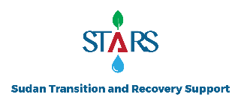 | 
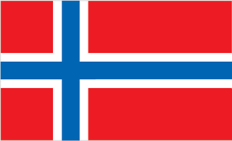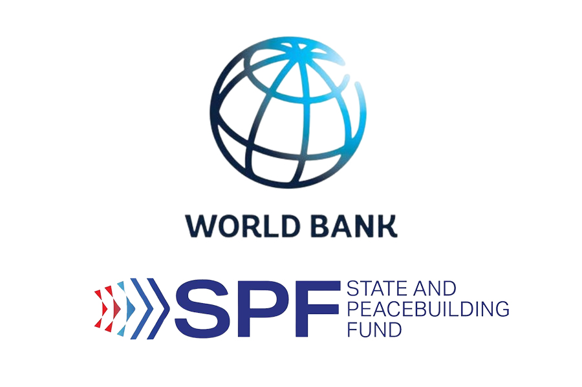

- Regarding Item No. 1 – Fabric Bag (Medium Size) with Mercy Corps & STARS logos: Could you please provide us with an image or drawing showing the required design, material, and dimensions (length, width, height) of the bag?
Also, we would appreciate it if you could share the logo files (Mercy Corps and STARS) to ensure accurate printing, or advise when these will be provided to the successful bidder.
Response: We have already incorporated sample for UNFPA to the issued RFQ document for bidder’s references. As for the Material type Nylon will be just fine. Regarding the estimated dimensions, please refer to the response given to Query No. 2 above.
- Item No. 4 – Bath Soap (500g): The specification states a weight of 500 grams per soap bar. This is significantly higher than the typical soap weight (100g – 150g) used in similar dignity kits.
Could you please confirm if the intended weight is indeed 500g, or if there might be a typo in the document? If it is a typo, please advise the correct required weight.
Response: the weight of the bath soap is revised to 125g. We have amended the RFQ document accordingly. Hence, bidders are advised to quote considering this revised weight of the soap bar; and brands such as Dettol or Lifebuoy are acceptable.
- In this regard, I would highly appreciate further clarification on some of the items listed in the tender, as certain materials are available in different brands and types, which requires additional technical clarification to ensure that the quotation submitted fully complies with the required specifications.
Response: As per the issued RFQ, specific brands are not required but all items must meet humanitarian quality standards; please carefully refer to the attached UNFPA note on dignity kits included in the RFQ document to ensure your compliance and the responses to the queries above.

